Lab Sheet: 3

Objectives

- To understand the use of COMMIT and ROLLBACK commands in transaction control.
- To use ORDER BY and GROUP BY clauses in SQL queries.
- To understand DCL commands (GRANT, REVOKE) and the use of SAVEPOINT.
- To understand and implement JOIN operations in SQL.

Instructions

Open your preferred Database Management System (DBMS) tool.

- Create the required tables: TEACHER, SALES, DEPARTMENTS, and EMPLOYEES.
- Insert suitable records into each table.
- Execute the SQL commands for transaction control, privilege control, grouping, sorting, and joins.
- Observe the output after each operation such as ROLLBACK, COMMIT, SAVEPOINT, GRANT, and REVOKE.

DDL Questions (Data Definition Language)

- Create the TEACHER table with the following attributes:
(Name, DeptNo, Date_of_Joining, DeptName, Location, Salary).
- Create the SALES table with the following attributes:
(Sales_No, Salesname, Branch, Salesamount, DOB).
- Create the DEPARTMENTS table with the following attributes:
(dept_no, dept_name, dept_location).
- Create the EMPLOYEES table with the following attributes:
(emp_id, emp_name, emp_salary, dept_no).

DML Questions (Data Manipulation Language)

From TEACHER Table

- Insert five records into the TEACHER table.
- Give an increment of 25% salary to teachers working in the Mathematics department.
- Give an increment of 15% salary to teachers working in the Commerce department.

From SALES Table

- Insert five records into the SALES table.
- Calculate the total sales amount in each branch.
- Calculate the average sales amount in each branch.
- Display the Salesname and DOB of salesmen born in the month of December with date format like 21-Dec-09.
- Display the Salesname and DOB of salesmen in alphabetical order of the month.

From JOIN Operations

- Display employee details and department details where the department numbers are the same in both tables.
- Display the employee name and department name using a LEFT OUTER JOIN.
- Display the employee name and department name using a RIGHT OUTER JOIN.
- Display the details of employees who draw a salary greater than the average salary.

TCL Questions (Transaction Control Language)

- Perform the ROLLBACK command on the TEACHER table.
- Perform the COMMIT command on the TEACHER table.
- Write a query to implement a SAVEPOINT.

DCL Questions (Data Control Language)

- Write a query to grant all privileges on the EMPLOYEES table to DEPARTMENTS.
- Write a query to grant selected privileges on the EMPLOYEES table to DEPARTMENTS.
- Write a query to revoke all privileges on the EMPLOYEES table from DEPARTMENTS.
- Write a query to revoke selected privileges on the EMPLOYEES table from DEPARTMENTS.

ANSWERS
DDL Questions (Data Definition Language)

1. Create the TEACHER table with the following attributes: (Name, DeptNo, Date_of_Joining, DeptName, Location, Salary).
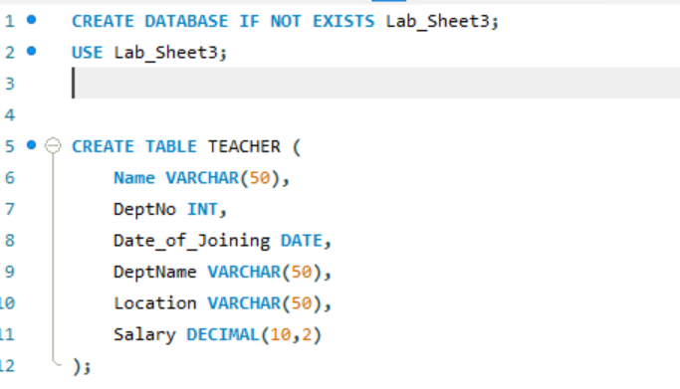
2. Create the SALES table with the following attributes: (Sales_No, Salesname, Branch, Salesamount, DOB).
DROP TABLE IF EXISTS SALES;
CREATE TABLE SALES (
Sales_No INT PRIMARY KEY,
Salesname VARCHAR(50),
Branch VARCHAR(50),
Salesamount DECIMAL(10,2),
DOB DATE
);

3. Create the DEPARTMENTS table with the following attributes: (dept_no, dept_name, dept_location).
DROP TABLE IF EXISTS DEPARTMENTS;
CREATE TABLE DEPARTMENTS (
dept_no INT PRIMARY KEY,
dept_name VARCHAR(50),
dept_location VARCHAR(50)
);

4. Create the EMPLOYEES table with the following attributes: (emp_id, emp_name, emp_salary, dept_no).
DROP TABLE IF EXISTS EMPLOYEES;
CREATE TABLE EMPLOYEES (
emp_id INT PRIMARY KEY,
emp_name VARCHAR(50),
emp_salary DECIMAL(10,2),
dept_no INT
);
DML – TEACHER Table Operations

From TEACHER Table
1. Insert five records into the TEACHER table.
QUERY:
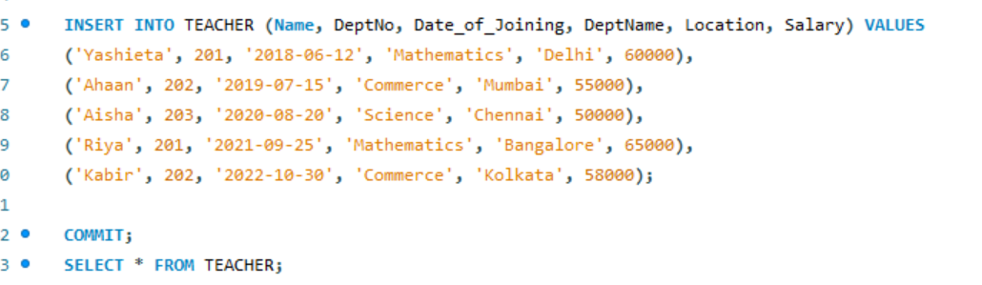
OUTPUT:
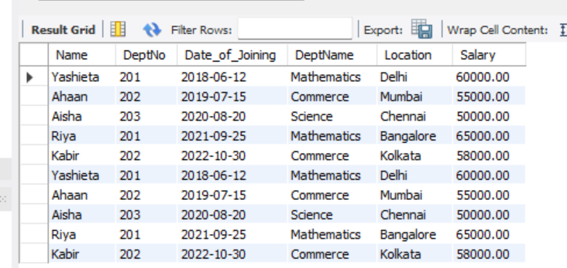
2. Give an increment of 25% salary to teachers working in the Mathematics department.
QUERY:
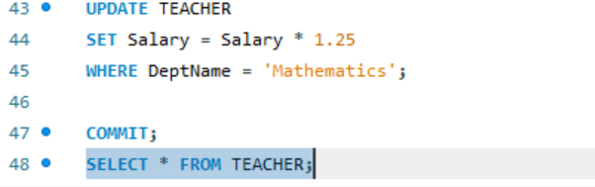
OUTPUT:
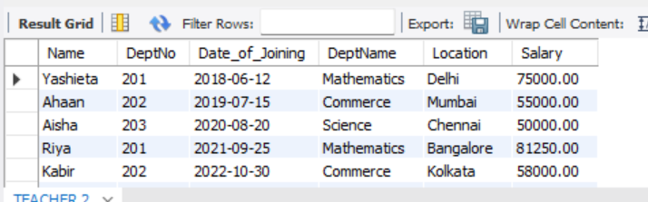
3. Give an increment of 15% salary to teachers working in the Commerce department.
UPDATE TEACHER
SET Salary = Salary * 1.15
WHERE DeptName = 'Commerce';

SELECT * FROM TEACHER;

From SALES Table
Q1. Insert five records into the SALES table.
QUERY:
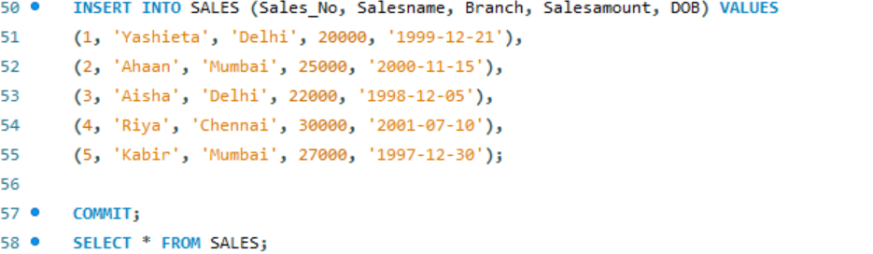
OUTPUT:
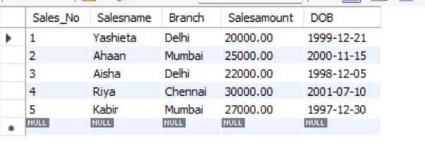
Q2. Calculate the total sales amount in each branch.
SELECT Branch, SUM(Salesamount) AS Total_Sales
FROM SALES
GROUP BY Branch;

Q3. Calculate the average sales amount in each branch.
SELECT Branch, AVG(Salesamount) AS Avg_Sales
FROM SALES
GROUP BY Branch;

OUTPUT:
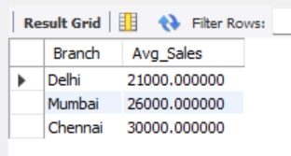
Q4. Display the Salesname and DOB of salesmen born in December (format: 21-Dec-09).
SELECT Salesname, DATE_FORMAT(DOB,'%d-%b-%y') AS DOB
FROM SALES
WHERE MONTH(DOB) = 12;
OUTPUT:
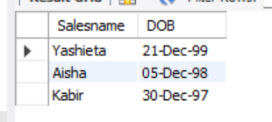
Q5. Display the Salesname and DOB of salesmen in alphabetical order of the month.
SELECT Salesname, DATE_FORMAT(DOB,'%d-%b-%y') AS DOB
FROM SALES
ORDER BY MONTH(DOB), DAY(DOB);
OUTPUT:
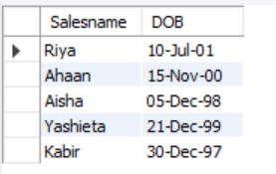

From JOIN Operations

Q1. Display employee details and department details where the department numbers are the same.
SELECT e.emp_id, e.emp_name, e.emp_salary, d.dept_name, d.dept_location
FROM EMPLOYEES e
JOIN DEPARTMENTS d
ON e.dept_no = d.dept_no;

OUTPUT:
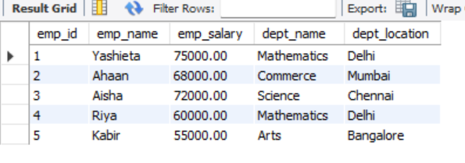
Q2. Display employee name and department name using LEFT OUTER JOIN.
SELECT e.emp_name, d.dept_name
FROM EMPLOYEES e
LEFT JOIN DEPARTMENTS d
ON e.dept_no = d.dept_no;
OUTPUT:
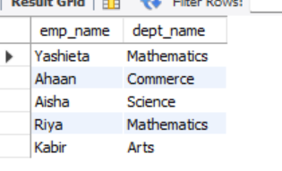

Q3. Display employee name and department name using RIGHT OUTER JOIN.
SELECT e.emp_name, d.dept_name
FROM EMPLOYEES e
RIGHT JOIN DEPARTMENTS d
ON e.dept_no = d.dept_no;
OUTPUT:
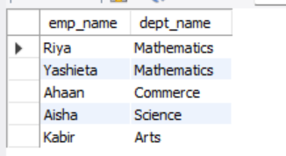
Q4. Display details of employees who draw a salary greater than the average salary.
SELECT *
FROM EMPLOYEES
WHERE emp_salary > (SELECT AVG(emp_salary) FROM EMPLOYEES);
OUTPUT:
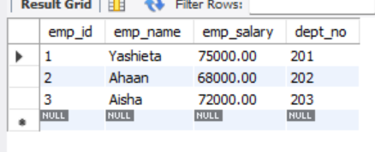
TCL Questions (Transaction Control Language)

Q1. Perform the ROLLBACK command on the TEACHER table.
SET autocommit = 0;

INSERT INTO TEACHER VALUES('TestUser', 105, '2023-01-01', 'Arts', 'Pune', 40000);

ROLLBACK;
OUTPUT:
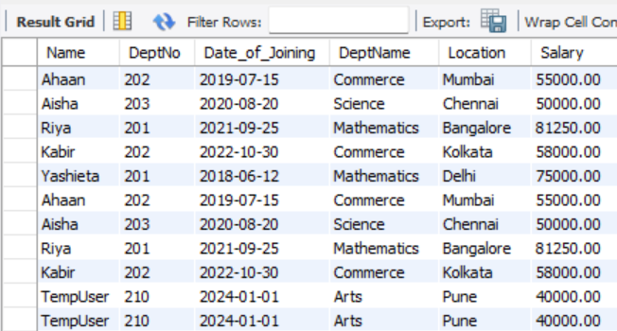

Q2. Perform the COMMIT command on the TEACHER table.
SET autocommit = 0;

INSERT INTO TEACHER VALUES('TestUser2', 106, '2023-02-01', 'Science', 'Mumbai', 45000);

COMMIT;
OUTPUT:
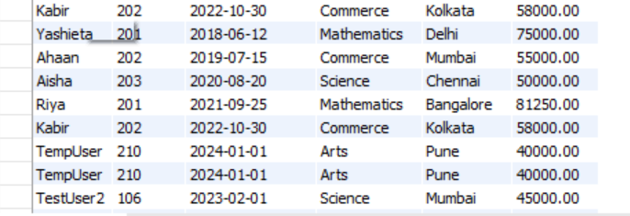

Q3. Write a query to implement a SAVEPOINT.
SET autocommit = 0;

INSERT INTO TEACHER VALUES('TempUser', 107, '2023-03-01', 'Commerce', 'Delhi', 42000);

SAVEPOINT SP1;

ROLLBACK TO SP1;
COMMIT;

DCL Questions (Data Control Language)

Q1. Grant all privileges on EMPLOYEES table to DEPARTMENTS.
GRANT ALL PRIVILEGES ON DBMS_Lab3.EMPLOYEES TO 'departments_user'@'localhost';

Q2. Grant selected privileges (SELECT, INSERT) on EMPLOYEES table to DEPARTMENTS.
GRANT SELECT, INSERT ON DBMS_Lab3.EMPLOYEES TO 'departments_user'@'localhost';

Q3. Revoke all privileges on EMPLOYEES table from DEPARTMENTS.
REVOKE ALL PRIVILEGES ON DBMS_Lab3.EMPLOYEES FROM 'departments_user'@'localhost';

Q4. Revoke selected privileges (INSERT) on EMPLOYEES table from DEPARTMENTS.
REVOKE INSERT ON DBMS_Lab3.EMPLOYEES FROM 'departments_user'@'localhost';

